Mounting the Sidecar to the Motorcycle
People of all levels of technical and engineering skill have been mounting, bolting, welding, wiring, gluing, scotch-taping or otherwise affixing sidecars to motorcycles for almost 100 years. As with so many things, there truly is nothing new under the sun.
The 4-Point System:
For motorcycles, the safest and surest way to spread the weight and force of the sidecar over the structural frame of the motorcycle is the common 4-point attachment system.
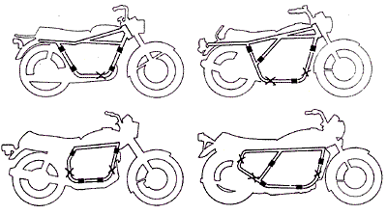
Attachment points indicated on four basic frames. X indicates alternate attachment points.
The 4-point mount is used on all Cozy sidecars for motorcycles. (Scooters employ a similar system of front and rear mounts to spread the load, with changes to the front mount to adapt for the unique frame structure of the scooter.)
Cozy sidecars are supplied with mounts for a full frame, tube-frame motorcycle. Cozy Canada can supply a "universal" mounting adapter that easily marries the Cozy sidecar mounts with available mounting points on most frame motorcycles. The same universal mounting adapters are employed on sport bikes and touring bikes where fabricated sub-frames are added to the motorcycle which otherwise dispenses with a bottom frame and instead uses its engine as part of the structural frame.
Inadequate or improperly affixed mounts can stress the motorcycle's frame and perhaps bend or damage this, but any well-secured 3 or 4-point mounting system will solidly HOLD the sidecar onto the motorcycle in all but the most extreme situations.
Sidecar Weight
Cozy sidecars are manufactured with rugged steel frames and rolled steel bodies. The Rocket and Standard models (for motorcycles) weigh in at 80kg (about 180 pounds) empty. They match just fine with any motorcycle of 350cc or higher displacement. Some operators will carry ballast when there is no passenger to make turning behavior more predictable, but an attentive operator can easily adjust to the driving behaviour of the outfit no matter what the load.
In operation, the wheel and axle of the sidecar take additional weight when passengers are aboard or ballast is added, and in left turns when the centrifugal forces of the motorcycle push down on the right side. Most sidecars come with excellent wheels and bearings, and the Cozy Rocket and Standard models, when adequately mounted at 4 points, are rated to handle 200 pounds of load and the turning forces of a heavy touring motorcycle without difficulty.
Toe-In and Camber
Once the sidecar has been physically secured to the motorcycle with the 4 mounts, finer adjustments must be made to ensure straight running of your (now) 3-wheeled vehicle - this is the toe-in adjustment, which is easily carried out without special tools. Incorrect adjustment can cause abnormal tire wear or hard steering. Really bad adjustment will manifest itself right away as a marked tendency to push the outfit to the right (no toe-in or toe-out) or heavy tire wear (too much toe-in).
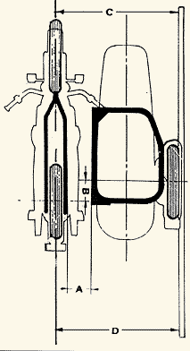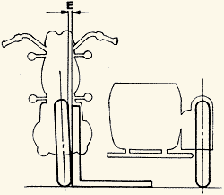
Camber (or the respective vertical angles of the motorcycle and sidecar) is adjustable – in practice - within a fairly wide range of tolerance. This is so because no matter how finely adjusted the motorcycle and sidecar, once out on the road the camber of the road itself comes into play, and this can vary widely and quickly. Also, the camber of the sidecar outfit will change depending on loading (is there a passenger on the bike? a passenger in the sidecar?). Making allowance for varying camber due to road conditions or loading is soon instinctively done by the operator. As for setting up the outfit, the motorcycle and sidecar must be set so that the bike is generally upright or leaned slightly outward, and the sidecar axle generally horizontal when the sidecar is empty.

