How to Attach a Cozy sidecar to a Vespa
You may need to readjust the toe-in and lean if the sidecar has already been mounted. I would also suggest doing any repairs/upgrades/maintenance on the scooter before mounting the sidecar. It is much easier to work on with no sidecar attached.

Before the sidecar
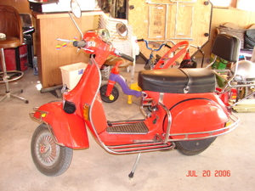
Scooter, 1979 Vespa P200E
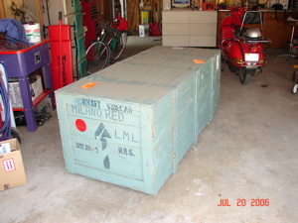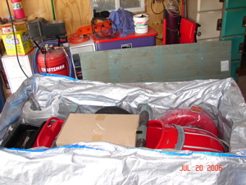
Sidecar in the crate

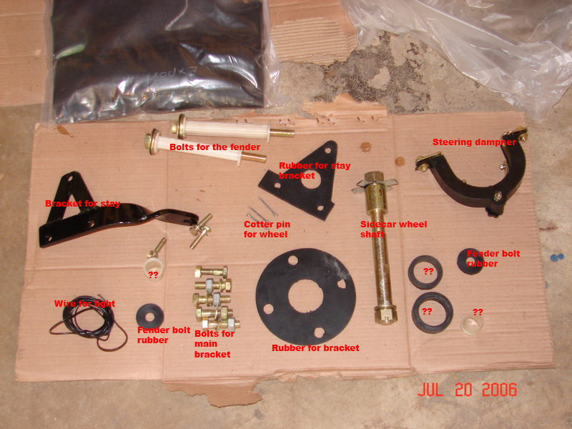
Parts
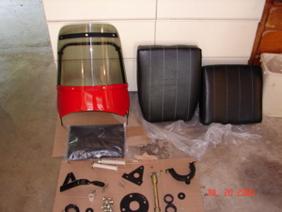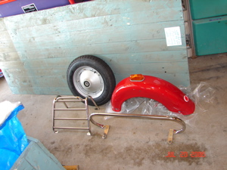
Windshield(if purchased), seats, cover
Fender, wheel, luggage rack, crashbar for fender
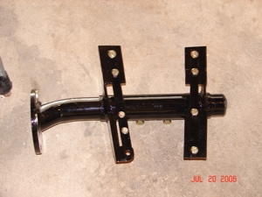
The bracket, mount it with the wider part (on the left in the picture) to the rear of the scooter.
The metal plates will be on top of the scooter floorboard, so it should (from bottom to top): sidecar bracket, scooter frame, metal plate.

Attach the sidecar to the scooter
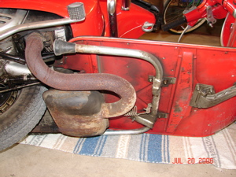
Pic of bottom of scooter before sidecar the hardware is mounted
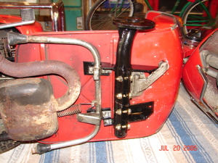
Lay the scooter down and remove the centerstand. Attach the sidecar bracket to the scooter, fit the rear bolts of the sidecar bracket to the two holes of the centerstand. Refit the center stand with the longer portion of the clamp to the rear of the scooter (or leave the centerstand off).
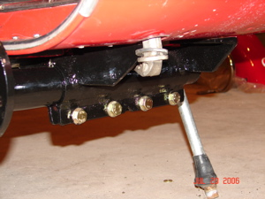
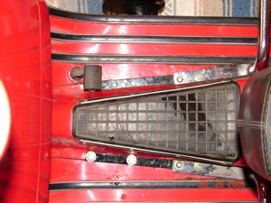
Drill new holes for the remaining bolts of the sidecar bracket (use 3/8" bit) and attach bolts
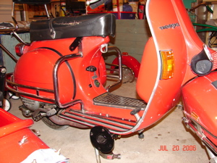
Scooter with sidecar mount
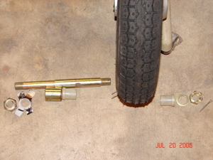
Assemble the side car wheel (parts are laid out in order). Grease the bearings too.
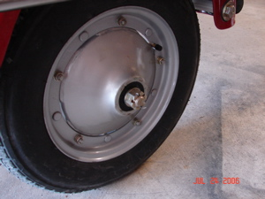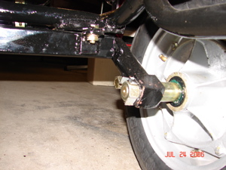
Be sure to use the cotter pin on the outer nut and bend the tabs over the nut on the inner nut
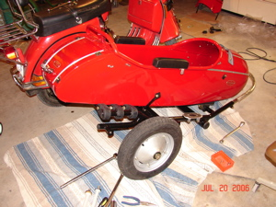
The wheel is on
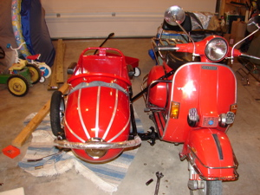
Attach the sidecar with the 4 bolts and rubber washer. Better get help on this one
Tighten the main bolts.
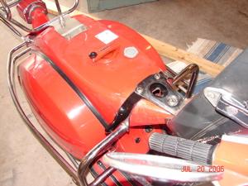
Attach the sidecar stay to the seat bolts of the scooter.

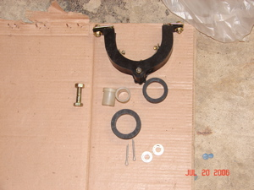
Old style Vespa dampening unit not included
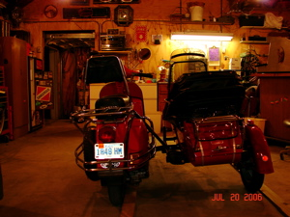
Scooter needs to lean out about 2 degrees picture shows way too much lean out

Adjust the toe-in (recommended is 3/4" to 1-1/4")
Check tire pressure in all tires
Front: 20-22 psi
Rear: 28-30 psi
Sidecar: 20-22 psi
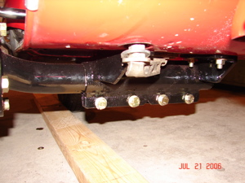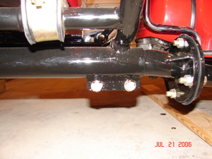
To Adjust Lean in/Lean out
Loosen the main bolts on the scooter (left picture) and the bolts on the sidecar (right picture). Twist the tube
Lay a board or other stright-edge alongside the sidecar wheel and a board alongside the front and rear scooter wheels. Initial distance was 40.5" front 42.5" back
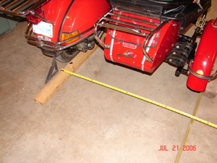
Measure distance between inside of rear wheel on the scooter and the inner edge of the board.
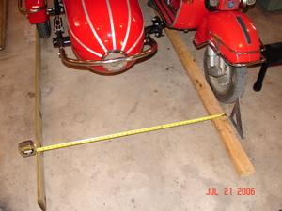
Measure the distance from the inside of the front wheel on the scooter to the inner edge of the board or better still use 2 8 foot fluorescent light bulbs their cheap and straight tape them 1 to the back wheel of scooter and 1 to wheel of sidecar.
The difference in distance is the toe-in. Twist the center connector to adjust the toe-in. I went with 1" toe-in.

Adjust the lean
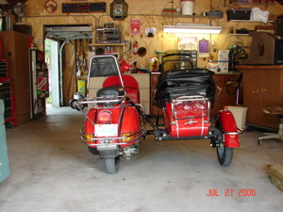
To adjust the lean, loosen the tie-rod bolt on the stay and push and shove and try and try to adjust the lean.
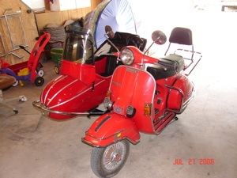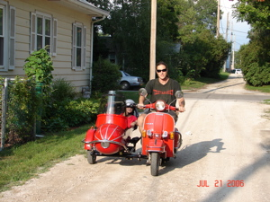
It rides really different compared to a solo bike, it will take some getting used to.

Re-adjust the bracket and toe-in
If the lean is too re-adjust the bracket and toe-in.
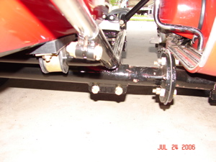
Bracket before adjustment, both scooter and sidecar tube are roughly the same height.
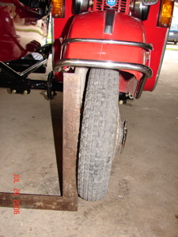
This amount of lean is slightly too much
To adjust the lean and toe-in.
1. Loosen the stay bracket (or disconnect it).
2. Loosen the four bolts on the scooter
3. Lift the sidecar up, this will cause the scooter tube to rotate.
4. Tighten one bolt on the scooter.
5. Loosen the bolts on the sidecar tube.
6. Adjust the sidecar down so it is somewhat level (front to back). Now the scooter and sidecar should be even and the lean should be alot less.
7. Check the toe-in (see above).
You may have to repeat steps #2-7 several times.
8. If the toe-in is good and the lean is good, retighten all the bolts for the bracket tubes.
9. Retighten the stay bolts.
10. Ride it and see if the adjustment is good, repeat if needed.
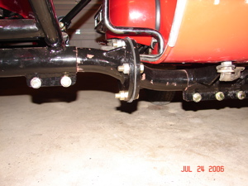
This is the bracket after adjustment, now the sidecar tube is higher than the scooter tube. This helped the lean-out alot. Now the toe-in is 1-1/2.
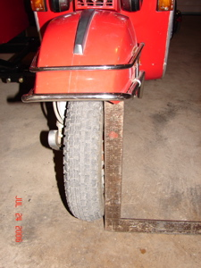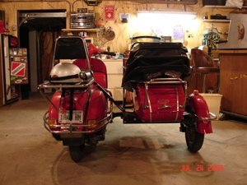
Lean-out after adjustment, the scooter now sits with a slight lean-in. This is about the right amount of lean-in.

Connect the light
To wire the light, just run wires from the light on the sidecar and connect to the tail light (the wire that is for the running light not the brake light). I ran the wire along the sidecar frame then inside the rear fender and through the hole for the tail light wires.

